Fpt partie I

Context, Requirements and State of Art

*Every person I work with knows something better than me.*

*My job is to listen long enough to find it and use it.*

Jack Nichols

The European population is getting older due to a conjunction of two factors. First, the decrease of births reduced the part of youth in the population. The second factor is the soon arrival of post-war "baby-boom" people to the age of retirement. Both of these factors imply a radical change in the age pyramid, and in the socio-economical environment of European countries. A consequence of this ageing of the population is an emergence of needs and requirements to face this global evolution.

Over the past few years, home automation technologies have been tending to democratize. More and more technical solutions are proposed to automate shutters, garage doors or lightning in houses. These facilities improved the quality of life of the European population. Now they sound like an interesting tool that could help and offer support to elderly people in their home.

As an introduction, chapter presents the Ambient Assisted Living and Home Automation domains, in order to extract some general requirements and outline the contribution of this thesis.

After this introduction, a state of the art in AAL projects, Home Automation, and software engineering approaches is realized in chapter **Erreur ! Source du renvoi introuvable.**. Chapter **Erreur ! Source du renvoi introuvable.** ends this first part with a summary of the state of the art, and announces the contribution of this thesis.

**Chapitre** **2**

# Introduction

Home Automation and the Ambient Assisted Living(AAL) domains have been of major influence on this work. Home Automation technologies offered a plethora of technical solutions with various constraints, while AAL brought substantial real life material in terms of requirements, needs, or use-cases.

This introduction chapter presents these domains in the first section. This presentation enables the section  to list some general requirements identified in these domains. Lastly, section  outlines the contribution of this thesis.

## 2.1 Ambient Assisted Living

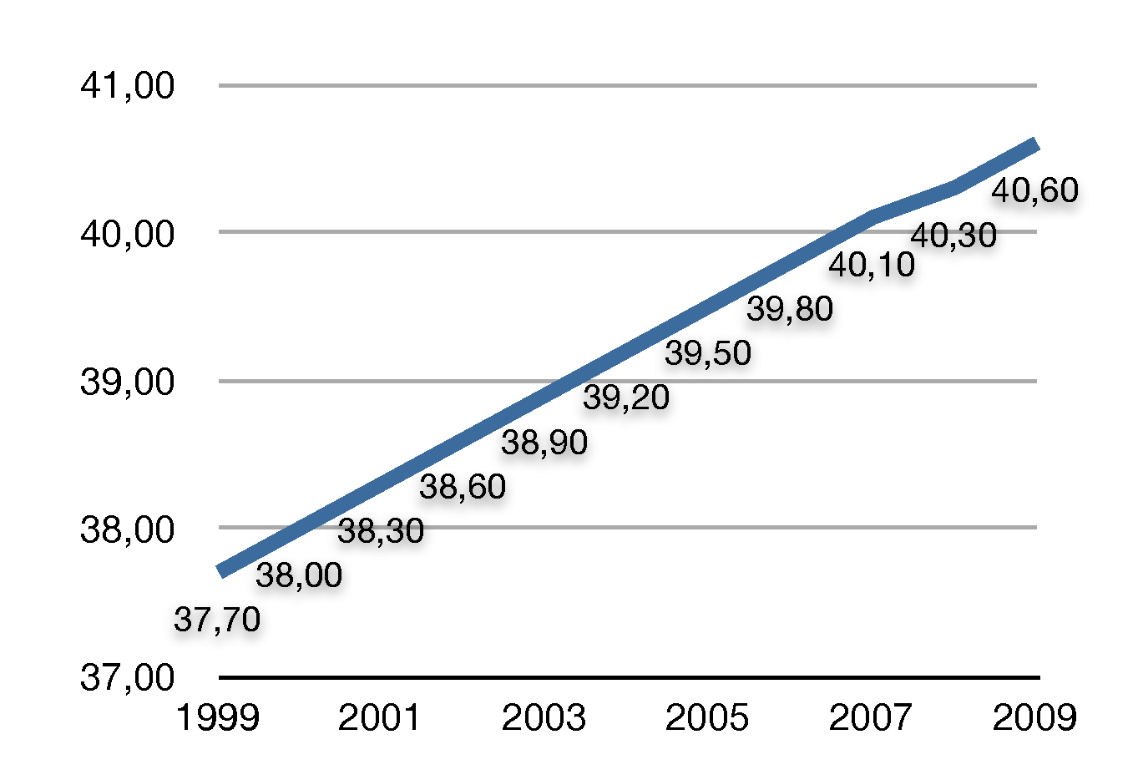

Fig. 2.1: Median Age of EU Population - Source Eurostat

### 2.1.1 The origins

According to Eurostat [1], the median age of European Union (27 countries) population has regularly been growing. From a median age of 37.7 years in 1999, it raises 40.6 years in 2009 as shown on figure . It is a fact, the European population is getting older each year. This ageing of the population is the result of the combination of several factors, among which are the ageing of baby-boomers, and the decrease of birth rates.

The **"Baby Boom"**

During the Second World War the birth rate stagnated, resulting in a similar number of birth from 1939 to 1945. This stagnation is visible on figure , at the level of people aged between 64 and 70. The "Baby Boom" describes the rapid and strong augmentation of the number of births that occurred after the Second World War, thus between 1945 and 1968. Actually, 4.9 million people were born in 1944 in EU, 7.6 million born in 1968 (plus 35.8%). People born during the "Baby Boom" are now(in 2011) 43 to 68 years old, and will soon retire.

**Decrease of birth rates**

As it can be noticed on figure , a decrease in birth rates started at the end of the sixties. From 7,664 million of persons born in 1968, the number of births fell down to 5,061 million in 2002 (minus 33.4%). In [**Erreur ! Source du renvoi introuvable.**], Xavier Bosch explains that this phenomenon, in Spain, is due to a multitude of factors such as an increase in the use of contraception, the raise of the number of single people, or the augmentation of the women part in the workforce.

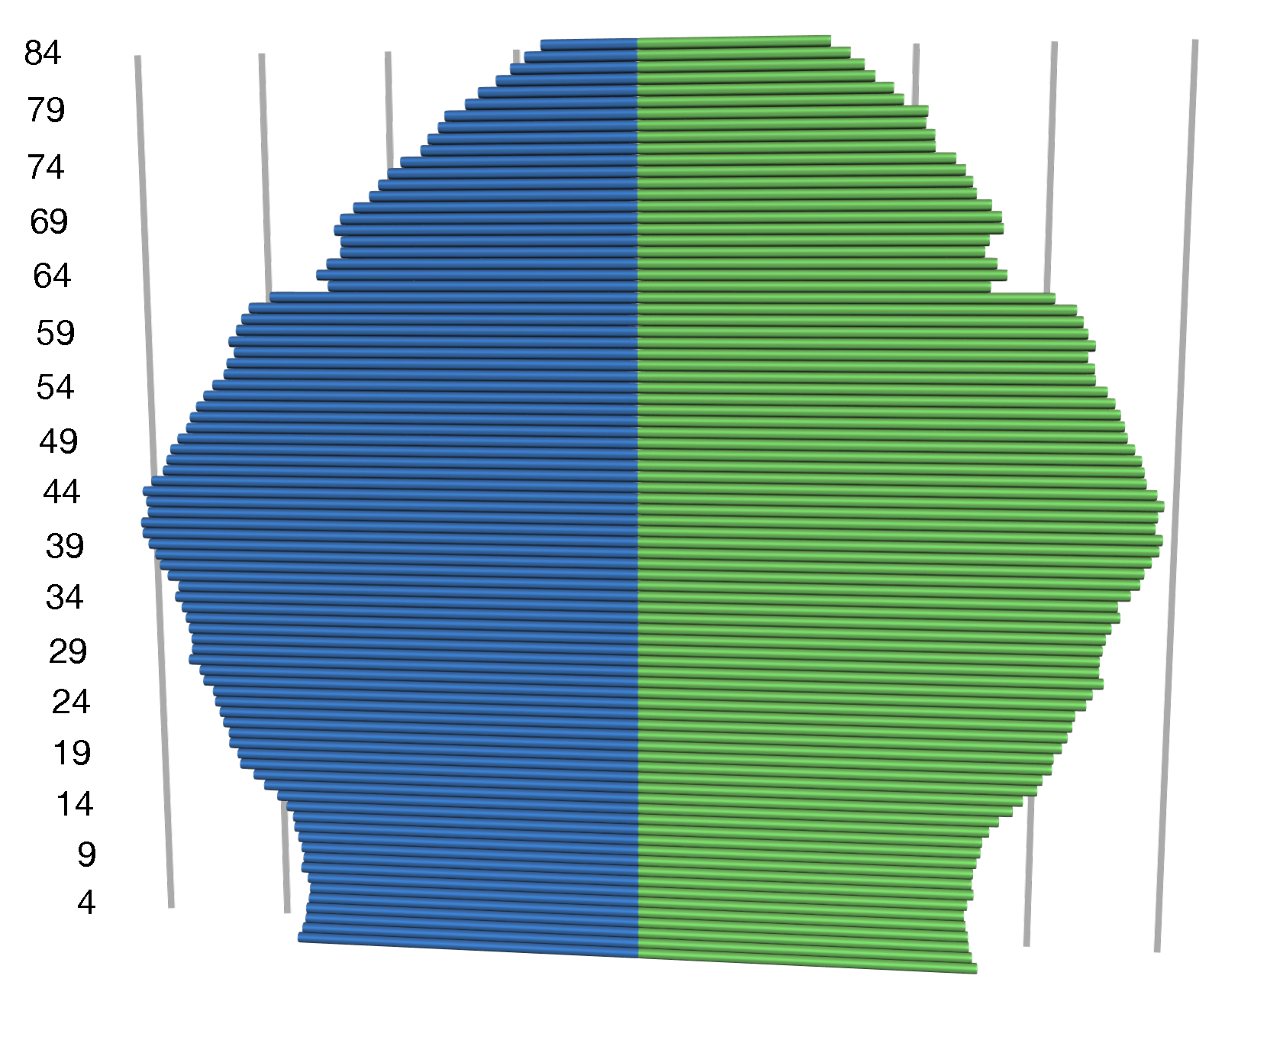

Fig. : Age Pyramid EU(27) in 2009. - Blue :M, Green :F - Source Eurostat

Europe will soon have to face the augmentation of the retired part of the population, and a simultaneous decrease of young people entering in the working life. By 2050, the number of people over 65 in the EU will increase by 70%, and the number of people over 80 will grow by 170 %.

In order to be ready on time, governments must address the economic and social implications of an ageing population. Now, they must prepare for increasing demands on healthcare, as a rapidly ageing society heralds growing populations with chronic diseases, disabilities, and increasing health needs.

### 2.1.2 The concept

The concept of aal can be described through 6 dimensions.

**Autonomy** By increasing the autonomy, the self-confidence and the mobility of elderly people, aal tends to extend the time people can live in their preferred environment.

**Activities** Maintaining physical or intellectual exercises helps elderly people to stay on a good health, and prevent from a decrease of capabilities.

**Assist** individuals at risk, by promoting a better and healthier lifestyle.

**Secure** Support and maintain the network around the individual, including family, friends and social activities, to enhance the security and prevent from social isolation.

**Support** carers, families and care organisations in their everyday activities.

**Streamline** the use of resources dedicated to elderly people, by increasing their efficiency and productivity.

There are many solutions to address these dimensions. Automation of some tasks can enforce the autonomy, and the use of mechanical helps can improve the mobility. Animators and health professionals can propose activities, support and assistance. Unfortunately, health care associations or companies have difficulties to hire people for these jobs. Indeed, qualified people are not enough numerous, and financial constraints are strong in this domain.

A workaround, in assisting both helped people and helpers, could be to use Home Automation technologies in conjunction with ICTs and human interventions. The section presents this domain.

## 2.2 Home Automation

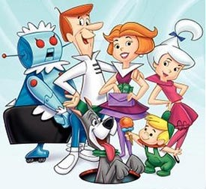

Fig. 2.3: The Jetsons

Do you remember the Jetsons ? This cartoon family was born in 1962, from William Hanna and Joseph Barbera. George and Jane were living in the *Skypad Apartments* in *Orbit City* with their children Judy and Elroy. Their housekeeping robot, Rose, was handling all chores not done by the numerous automated appliances triggered with some push-buttons. Apart from the fact that it is just a fiction cartoon, it well describes the idea of smart homes or home automation. Let us get further down into a bit more details about home automation, and see why it is still not applied in everyone’s house.

### 2.2.1 Application domains

Home automation has too long been perceived as presented in the Jetsons : a set of costly, useless, funny pieces of technology.

Obviously, personal home theatre, multi-room multimedia diffusion systems, smart coloured lighting controllers will always exist and make a good showcase of what is possible to do. Besides, a more utility-oriented home automation is soaring. Among others, home or building automation technologies ease the management of lighting control, shutter control, heating, ventilation, air conditioning, energy management, metering, monitoring, alarm/intrusion systems, household appliances, audio/video and lots more. However, people are not ready to pay for the automation of tasks they can execute by themselves.

Widely used in industry buildings and plants, the automation of the lighting or heating systems has brought substantial savings of energy and money. This industrial experience makes it possible to imagine the benefits of installing such kind of systems in homes. The minimization of power consumption with a maximisation of welfare is acceptable, even dreamed by everybody. By extension, alarm systems, automatic garage doors, shutters can also be managed this way, rendering a global and coherent service to inhabitants.

### 2.2.2 Technologies

The devices encountered in home automation originate from different business domains. M. Nagy says in [**Erreur ! Source du renvoi introuvable.**] that "A major problem is inherent heterogeneity [...] with respect to nature of components, standards, data formats, protocols, [...]". Indeed, it can be a problem through many aspects, but it is also a fantastic set of tools awaiting to be connected together.

**Communication Media**

Four main communication medium can be differentiated in home automation technologies : the *Bus*, the *Radio*, the *plc* and *Infrared*. Devices use these communication media to communicate with each other, and offer a technical functionality. The choice of a medium is linked to the constraints to address. For instance, a Bus link is highly reliable, but needs the wiring of the entire house. On the other hand, Radio communications do not need any additional wiring, but are less reliable and batteries have to be changed regularly.

**Plethora of protocols**

Historically, there are no home automation specific brand or manufacturer. They all come from different trades such as electricity or hvac control. According to the specific needs of their domains, each home automation manufacturer has developed a specific communication protocol for its devices to operate with each other. They also used several communication media to carry the communications. A simple consequence of that is the huge number of devices, protocols and medium available on the home automation market. Technical solutions proposed by the Home Automation domain are so numerous, that there may be a solution for each need, in almost each domain. Nevertheless, due to this great diversification, no common management tool exists so far, resulting on mono-manufacturer expensive close solutions, or no solution at all.

Even if home automation technologies have been existing for many years, no real standard has been released. Imposing a global standard, as it was the case for the IP protocol for example, seems to be the best way to address such an issue. Naturally, each domain has created its communication protocol adapted to each business concern. Thus, finding a common protocol, used and understood by all devices from all domains, appears to be a very rude task. And even if one finally emerges, developers will still have to deal with legacy devices using proprietary protocols.

Moreover, the old way manufacturers are thinking adds to the complexity of the problem. They still think that a close world (I mean non public protocol specifications) is a world that can be controlled. Indeed, it is true, but it is also a world that fewer and fewer people want to enter, because they are afraid of the captivity imposed by such solutions. Captive systems are often well tested, because of the restricted number of available devices, but there is also a risk for these components to be removed from the market one day. In these conditions, people could not replace these components with compatible others, and are thus really concerned with the sustainability of the adopted solution.

## 2.3 Identification of requirements

The domain of Home Automation requires a new breed of technology to easily manage installations, and answer to specific needs. The lack of such a tool, able to operate any home automation technology, and create solutions for specific needs of elderly people, makes marginal the adoption and use of these technologies. This absence of tool may be due to the complexity and number of requirements inherent to home automation systems. This section aims to identify a set of required properties for a software tool to be adopted by manufacturers, installers and users.

The requirements presented in this section had been identified in [**Erreur ! Source du renvoi introuvable.**]. This section completes the list and precise them.

**Interoperability**

Interoperability is described as the ability for systems to operate with each other. Even if system is quite a generic word and encompasses lots of things, the idea behind interoperability is simple. Given two or more systems, how to ensure each of them to be operable by another one ? For instance, if I have a light management system and another one for shutters, how to guarantee these systems to be able to communicate in order to be of use for the user.

A close environment, in which all devices come from the same manufacturer, avoids the problem. A communication interface, common to all components, also answers the question. The interoperability becomes a complex problem, when the environment is open, and when several technical concerns have to be handled in a single place(lighting and heating management for instance).

In the context of aal, each solution will be uniquely deployed, because each patient, each helped person has specific needs due to his environment or his diseases. Indeed, specialists in this domain will select different technical artefacts or services, according to each need of the person. Those elements of solution will have to cooperate one to each other in a single system, to perfectly fit the user’s needs, and this, whoever their manufacturer or whatever their communication protocol may be.

**Openness**

By openness, here is meant to make all offered functionalities available for third party applications, or different uses than the one basically thought. Too many times, systems are closed, and providers impose their clients to ask them for any evolution, even if another provider could do it. Keeping the system open to external contributions may indeed pull down the number of demands for system modifications or add-ons. Anyway, it is also a door for new unforeseen appliances adding a smart behaviour on top of a reliable set of functionalities.

This is a clear challenge in computer sciences, and in general when considering communications and interactions between objects or systems. The definition of a home-made interface fulfilling the requirements is easier than fitting into a good-practice, or a standard that does "almost what we want but not completely".

Openness is a strong requirement in home automation systems, as it has been in computers. Today, computer manufacturer would not create a specific connection port, not compatible with all other computers. Unless they want to create a new captive market.

**Adaptation**

In an ideal world, devices never fail, services are always available, and Internet is always accessible. As demonstrated every day, the world we are living in is not perfect. Software systems, or systems dealing with objects or services linked to everyday life actions, have to consider their execution environments. They should be able to dynamically adapt to changes around them while they are running, in order to maintain a given level of services or functionality as long as possible. Obviously, these adaptations should not require any reboot of the system, because the reboot could make all in house functionalities unavailable. Lastly, an adaptation is not intended to add or remove any system functionality permanently. Otherwise, it is an evolution.

Policies of execution or reactions of the system must be easily modifiable, in order to take into account any change in the user’s requirements. For instance, depending on the level of dependency of an elderly person, the system may completely, partially or not, automate the management of certain household functions such as heating or shutters management. This kind of change in the system behaviour has to be made simple, and operable by any authorized person, even with no specific skill in this domain.

Most of all, these changes during runtime must not affect the basic security functions execution (like emergency calls handling), neither in their behaviour, nor in their execution during adaptation.

Adaptations do not only concern technical elements, but also the user himself. Users are different. While some may be interested in new technologies, others are completely agnostic. When some are able to remember and learn how the system behaves, others may improve some memory loss. Where some have vision troubles, others experiment hearing limitations. Software systems should be able to take into account these disabilities and adapt to their evolutions and to users’ requirements.

**Evolution**

Evolution in the context of home automation and/or assisted living is a key requirement. Needs or uses are changing, protocols and technologies also. Some functionalities may finally be required, whereas others can become useless and need to be uninstalled. Security or communication protocols can be improved and deployed in new versions that have to be taken into account without needing to re-implement the entire system.

Moreover, systems deployed in a house or a building, in charge of its management and comfort of the inhabitants, have to be designed to serve during all the life of the building (even if hardware changes may be required). Therefore, they must be ready to accept future and unforeseen evolutions like installation of new services/functionalities for example.

**Variability Management**

No house or building is like any other. Because of structural or ground specificities, because of particular user’s need or just because no one would like to have exactly the same house as his neighbour. Thus, each installation will have specific devices deployed, using specific versions of protocols, and providing several functionalities. The development, by hand, of a specific control system for each installation is completely excluded. It would be too costly and error prone. A global management tool should exist to deal with the inherent variability of such systems.

People responsible for designing a solutions for an installation query, should have at their disposal some tools to help them in choosing devices to install, or assist them in devices selection from all the catalogues of all manufacturers.

**Remote Control**

More and more, people want to remotely access to their belongings. This is also true for their homes. They would like to be able to remotely check lights’ states, run a bath or switch on the alarm system they forgot.

In the context of building management facilities, specialized companies have different solutions to check the state of a building system. They either have a remote access to all systems, or check locally by hand. Obviously, the check by hand solution is no more viable in the context of our society. Systems deployed to control buildings or homes should have remote access possibilities (under access control and agreement) to allow for distant diagnosis, corrections, or evolution actions from a control centre.

**Distribution**

Today’s systems are more and more working with or on different execution platforms, and communicate with each other. This is particularly true for home automation. For redundancy reasons, and service level insurance, a building and even a house can be equipped with multiple independent, but connected controllers. These controllers can share the different functions to balance the loads on platforms, or offer a connection to a specific locally connected device. When a running platform fails, other platforms aware of its job can ensure the interim, until the original controller is back. Also, devices are getting smarter and may make decisions by themselves. As a consequence, decisions and control could be distributed on several smart equipments.

**Safety & Security**

As presented in the context of this work, safety and security are very important requirements for home automation systems. Actually, they have to be themselves safe and secured to be able to play their role in difficult situations, and improve the security and safety of people and goods. A minimum service level has to be guaranteed, for inhabitants not to stay stuck in the house in case of emergency. Moreover, access policies of the system have to be sufficient to avoid unauthorised access, and quiet enough to not become a constraint for authorized carers.

Several tools like simulators, tests, or model checking, can be used to check and improve the reliability and the safety of such kind of systems.

**Acceptability & Accessibility**

In the domain of home automation, deployed solutions, whatever their nature, have to consider interactions with all inhabitants. Being children, teenagers, young active, parents, retired or old people, all of them must be able to interact with the system. Checks have to be performed on any solution proposed, to ensure all users can control, or get information from the system, and keep the control.

New requirements for software are emerging from the democratization of home automation technologies. The evolution of the software during the building lifetime, its adaptation to cope with changes in its execution environment, the huge variability of technologies, and protocols to be guaranteed to inter-operate, are triggering new challenges for software engineering.

## 2.4 Contribution of this thesis

Software can no longer be built once for all. Customizable, reliable and personalized solutions have to be deployed in short terms, to fit at any time to changes in user’s needs or in the environment. Moreover, the specificities of each installation make it very hard to create a unique software able to cope with all technologies, concerns(such as energy consumption) or unpredictable evolutions.

In the electronic domain, the number of components, and their always-possible connectivity have offered technicians and engineers, means to create various solutions. Even many years after their assembly, electronic devices can still be repaired or completed with new features. The proposition made in this thesis is to take advantage of the electronic way of doing to improve the flexibility of software systems while keeping a high level of safety and security.

To this end, the contribution of this thesis can be described by three aspects  :

- A constraint-relaxed component model that leverage the software flexibility, by offering ways to connect any component to any other. This aspect addresses issues from interoperability and evolution requirements

- Modelling tools to create, modify and simulate component assemblies, check their consistency and validity before their (re-)deployment at runtime. Safety and security, as long as variability management are requirements covered by this aspect of the contribution.

- An execution environment built over a Service-Oriented runtime, to support the proposed component model, cope with requirements of adaptation and evolutions at runtime.

1. http ://epp.eurostat.ec.europa.eu/portal/page/portal/eurostat/home